|  |  |  |  |  |  |
| --- | --- | --- | --- | --- | --- |
| **CONTENT** | | |  |  |  |
| 1. Introduction | |  |  |  | 2 |
| 1.1. Purpose | |  |  |  | 2 |
| 1.2. Scope | |  |  |  | 2 |
| 1.3. Overall Scope | | |  |  | 3 |
| 2. USE CASE & ACTION DIAGRAM | | |  |  | 4 |
| 2.1. Use Case | | |  |  | 4 |
| 2.2. Action Diagram | | | |  | 5 |
| 3. DECOMPOSITION DESCRIPTION | | | |  | 6 |
| 3.1 Entity Relationship Diagram (ERD) | | | |  | 6 |
| 3.2. Data Decomposition | | | |  | 6 |
| 4. DETAILED DESIGN | |  |  |  | 9 |
| 4.1 Entire Menu 9 | | | | | |
| 4.1.1 Screen Design | | | |  | 11 |
| 5. INTEGRATION REQUIREMENT | | |  |  | 14 |
| 5.1 Introduction | | | |  | 14 |
| 5.2 Terms and Definition | | | |  | 14 |
| *Appendix A* |  |  |  |  | 15 |

1. **INTRODUCTION**

This Software Design Document (SDD) outlines the technical design and development of Admin web page for PISM Donation System that enables the management and monitoring of the donation transaction through a web-based application.The admin web page will allow administrators to view and manage donation records,as well as to manage user's information.The SDD will cover the admin web page’s layout,functionality and integration with rest of the donation system.The main target users of the system will be system administrator and developers.This document covers the purpose,scope and SDD document introduction.

**1.1 Purpose**

The purpose of this document is to show how the system will be structured to meet the requirement.It translate the requirement into a description of the software structure,software components,interface,and data required in the implementation phase.Design description is used to present a system that can be explained as a group of design entities,each possessing properties and relationship.To summarize the model properties and relationships for each design entity are described by a standard set of attributes. A design description is complete when all attributes have been identified for all entities.In a complete SDD, each requirement must be traceable to one or more design entities.

In conclusion,the SDD is to be the clear and detailed representation of the overall blueprint for the implementation activities.it’s a valuable document that helps to keep project organized and final product to meet the requirement.

**1.2 Scope**

The Admin web page is a web-based application and will be deployed online on the internet and intranet through a secure network.This application will be used by PISM Administration.In this document,the system will cover modules such as the list below

**1.3 Overall Scope**

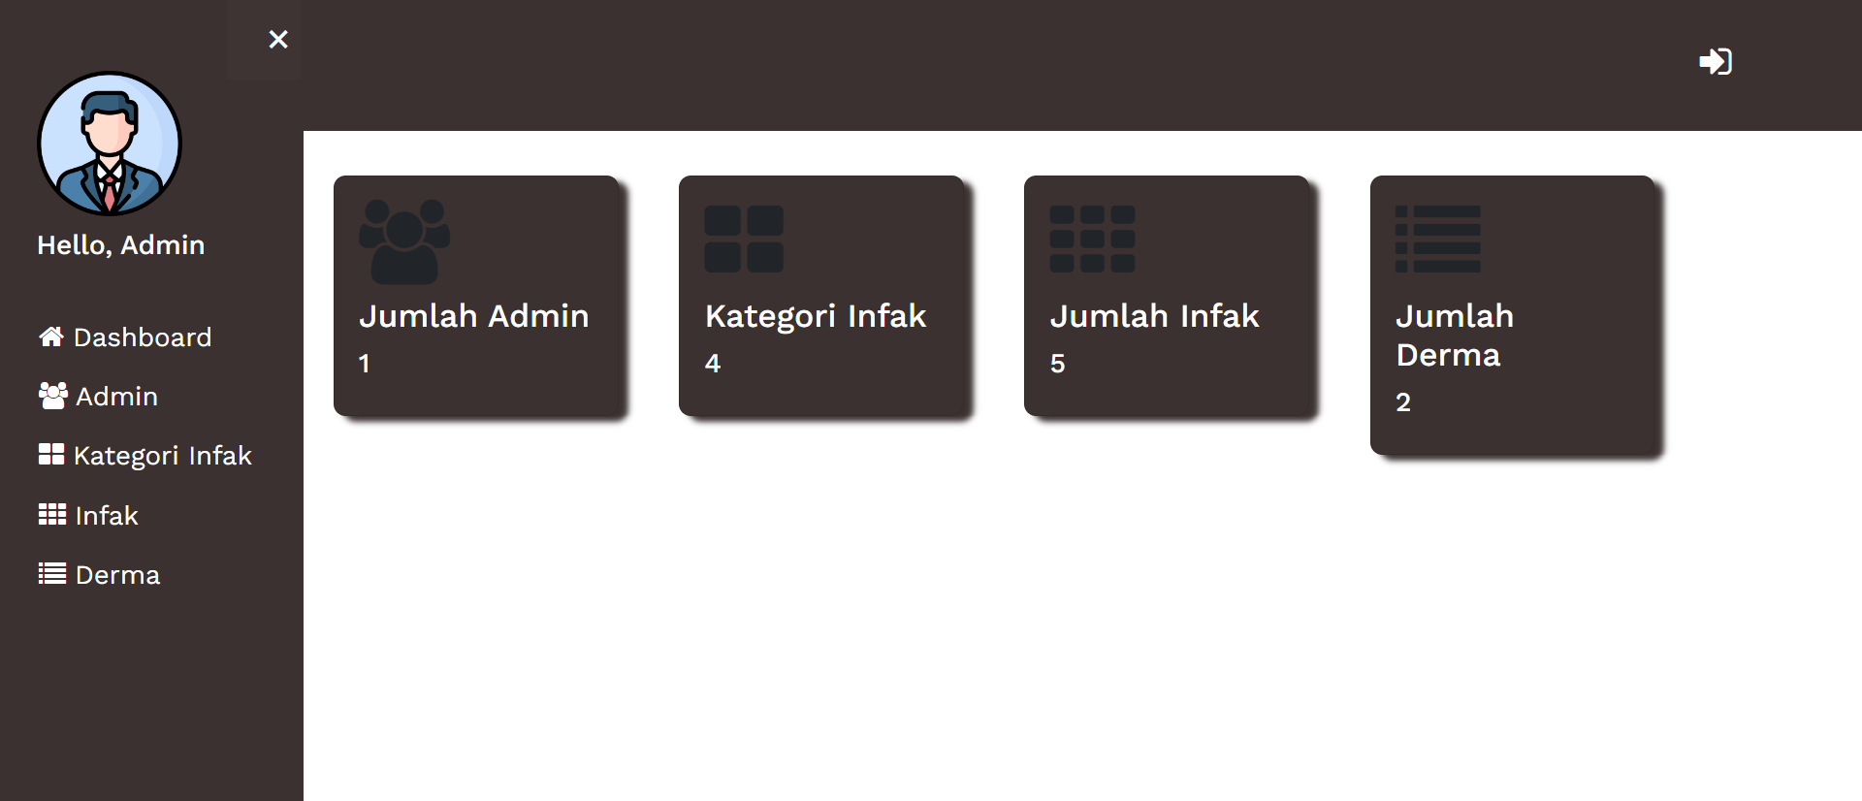

1. Dashboard

2. Admin

3. Kategori Infak

4. Infak

5. Derma

**2.0 USE CASE & ACTION DIAGRAM**

**2.1 USE CASE**

Admin

Logout

View Derma list

Add infak

Add Category infak

View User information

Add User

Login

User

Logout

View User information

View Derma list

Add infak

Add Category infak

Login

**2.2 ACTION DIAGRAM**

|  |  |  |
| --- | --- | --- |
| **Timeline** | **Peranan** | **Aktiviti** |
|  | * Admin | Add Admin   * All users |
| * Admin | Add Category Infak   * All Jenis Infak |
| * Admin | Add Infak   * All infak |
| * Admin | View Derma   * View All Derma list |
| * Admin | View User Information   * View all User information |
| * Admin | Logout |

**3.0 DECOMPOSITION DESCRIPTION**

**3.1 Entity Relationship Diagram (ERD)**

Refer to ***Appendix A***

**3.2** **Data Decomposition**

This section shows all the table for the module

|  |  |
| --- | --- |
| **Table Name** | **Module** |
| PISM_ADMIN | PISM Administrative Web |
| JENIS_INFAK | PISM Administrative Web |
| PISM_INFAK | PISM Administrative Web |
| PISM_DERMA | PISM Administrative Web |

1. **Table Name** : PISM_ADMIN

**Description** : Use to view all registered admin

|  |  |  |  |
| --- | --- | --- | --- |
| **Column Name** | **Column Type** | **Width** | **Description** |
| ID_ADMIN | NUMBER | 38 | ID for every admin |
| EMAIL | VARCHAR2 | 255 | Email of admin |
| PASSWORD | VARCHAR2 | 255 | Password of admin |
| NAME | VARCHAR2 | 255 | Name of admin |

**Trigger** : None

1. **Table Name** : JENIS_INFAK

**Description :** Table for storing infak category

|  |  |  |  |
| --- | --- | --- | --- |
| **Column Name** | **Column Type** | **Width** | **Description** |
| JENIS_INFAK | NUMBER | 38 | ID for every infak |
| NAMA_INFAK | VARCHAR2 | 255 | Name for every infak |

**Trigger** : None

1. **Table Name** : PISM_INFAK

**Description** : Table for storing infak information

|  |  |  |  |
| --- | --- | --- | --- |
| **Column Name** | **Column Type** | **Width** | **Description** |
| ID_INFAK | NUMBER | 38 | ID for every row |
| IMAGE | VARCHAR2 | 255 | Image of the infak |
| JENIS_INFAK | VARCHAR2 | 255 | Category of the infak |
| TOTAL | VARCHAR2 | 255 | Total of the infak |
| DESCRIPTION | VARCHAR2 | 255 | Description of the infak |
| NAMA_INFAK | VARCHAR2 | 255 | Name of the infak |

**Trigger** : None

1. **Table Name** : PISM_DERMA

**Description** : Table used to store Derma information of user

|  |  |  |  |
| --- | --- | --- | --- |
| **Column Name** | **Column Type** | **Width** | **Description** |
| ID_DERMA | NUMBER |  | ID for every row |
| DERMA_DATE | DATE |  | Date of the donations |
| JENIS_INFAK | VARCHAR2 | 255 | Category of the infak |
| TOTAL | NUMBER | 10 | Total of the donations |
| ID_INFAK | NUMBER |  | ID of the infak |
| NAMA_PENDERMA | VARCHAR2 | 255 | Name of the users |
| PHONE_NO | VARCHAR2 | 50 | The users phone number |
| PHONE_MODEL | VARCHAR2 | 255 | The model of the users phone |
| PHONE_MANUFACTURE | VARCHAR2 | 255 | The manufacturer of the users phone |
| PHONE_OS | VARCHAR2 | 255 | The operating system of the users phone |
| BANK NAME | VARCHAR2 | 255 | Name of the bank |
| BANK_DATE | DATE |  | Date of the payment |
| STATUS_TRANSAKSI | VARCHAR2 | 20 | The status of the transaction |

**Trigger** : None

**4. DETAILED DESIGN**

This section contains the detailed internal design of entity.It explains interface design,report design,processing and data.

**4.1 Main Menu**



|  |  |
| --- | --- |
| Menu ID : | home.php |
| Form ID : | module=academic&app=ISOA |
| Description : | Module that is used by admin |

|  |  |
| --- | --- |
| Menu Name : | Dashboard |
| Description : | Menu that is Used by admin |
| Sub-menu : | * Admin [view_Admin.php] * Kategori Infak [view_Jenis_Infak.php] * Infak [view_All_Infak.php] * Derma [view_All_Derma.php] |

**4.1.1.1 Screen Design**

**Screen ID :** view_Admin.php

**Description :** View all registered admin

**User :** Admin

**Screen:**

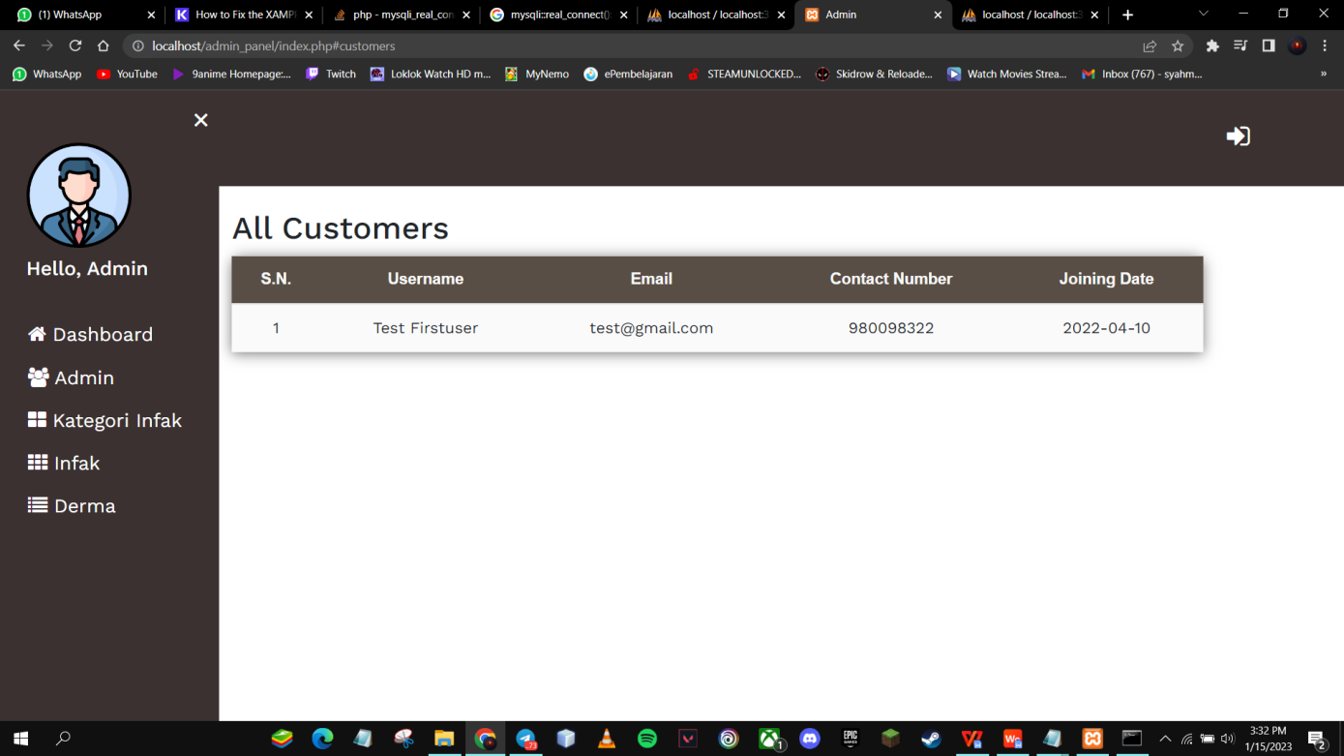

Click Here

**Table(s) :**

|  |  |  |  |  |
| --- | --- | --- | --- | --- |
| **Table Name** | **Select** | **Insert** | **Update** | **Delete** |
| PISM_ADMIN | x | x | x | x |

**Passed Parameter(s) :** None

**Screen ID :** view_Jenis_Infak.php

**Description:** Used by admin to view category of infak and also add new category

**Users :** Admin

**Screen:**

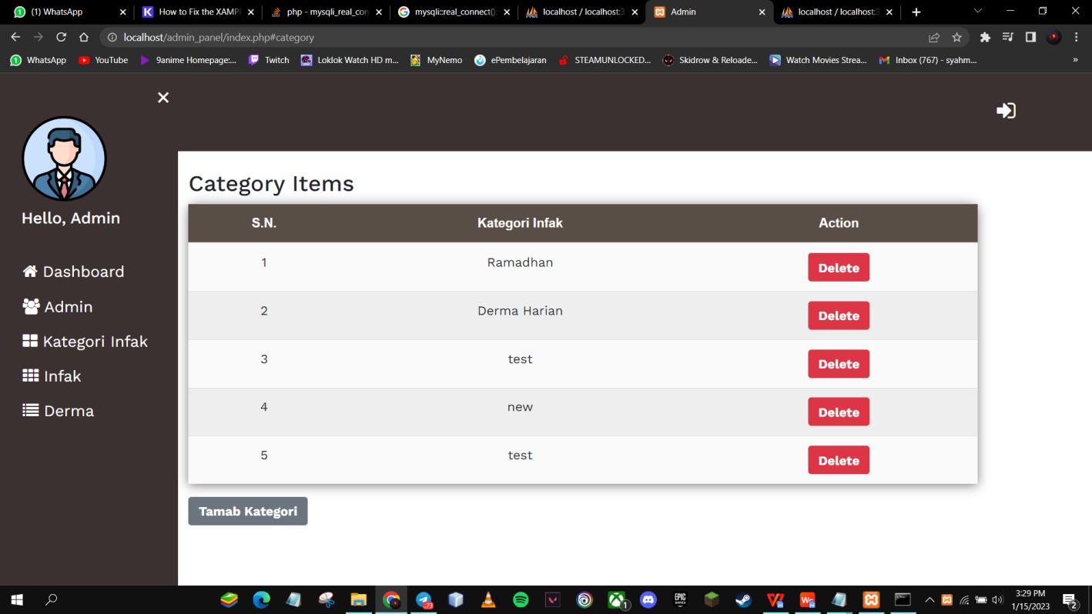

Click Here

**Table(s) :**

|  |  |  |  |  |
| --- | --- | --- | --- | --- |
| **Table Name** | **Select** | **Insert** | **Update** | **Delete** |
| JENIS_INFAK | x | x | x | x |

**Passed Parameter(s) :** None.

**Controller**

|  |  |
| --- | --- |
| **File Name** | add_Jenis_Controller.php |
| **Description** | Controller to add new kategory infak |

|  |  |
| --- | --- |
| **File Name** | Jenis_Infak_Delete_Controller |
| **Description** | Controller to delete infak kategori |

**Screen ID :** view_All_Infak.php

**Description:** View and add Infak.

**User:** Admin.

**Screen:**

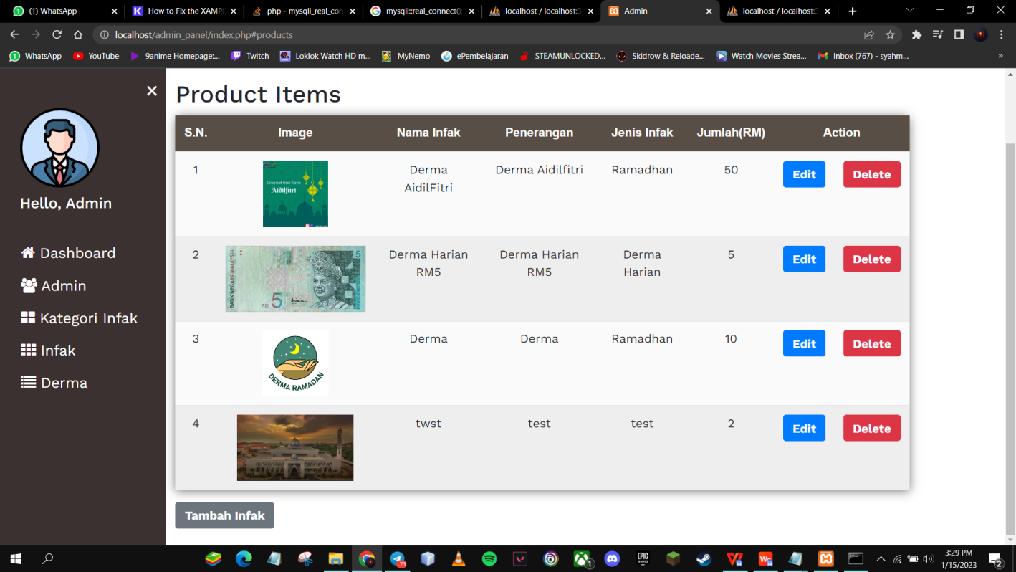

Click Here

**Table(s) :**

|  |  |  |  |  |
| --- | --- | --- | --- | --- |
| **Table Name** | **Select** | **Insert** | **Update** | **Delete** |
| PISM_INFAK | x | x | x | x |

**Passed Parameter(s) :** None

**Controller**

|  |  |
| --- | --- |
| **File Name** | add_Infak_Controller.php |
| **Description** | Controller to add new infak |

|  |  |
| --- | --- |
| **File Name** | Delete_Infak_Controller |
| **Description** | Controller to delete infak |

|  |  |
| --- | --- |
| **File Name** | update_Infak_Controller |
| **Description** | Controller to update existing infak |

**Screen ID :** view_All_Derma.php

**Description:** View all derma records.

**Users:** Admin

**Screen:**

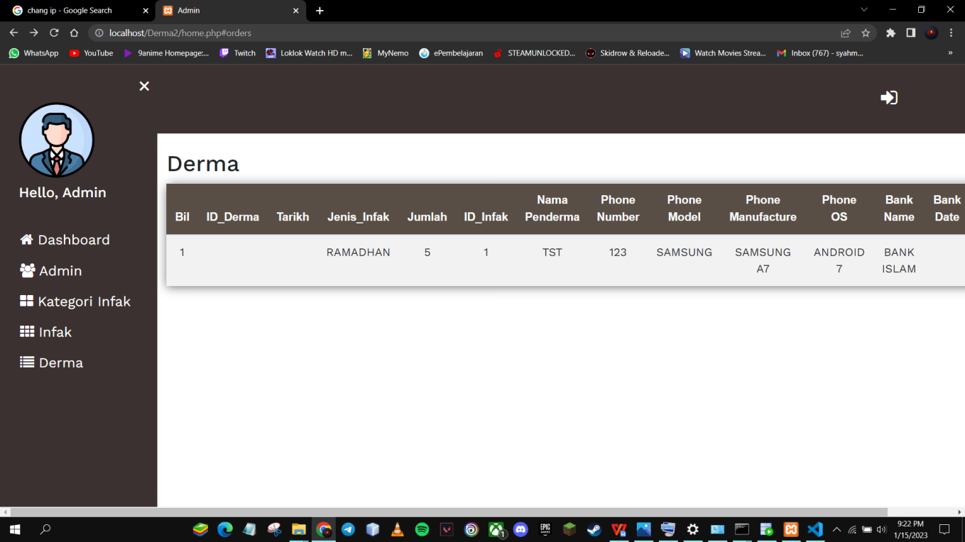

Click Here

**Table(s) :**

|  |  |  |  |  |
| --- | --- | --- | --- | --- |
| **Table Name** | **Select** | **Insert** | **Update** | **Delete** |
| PISM_DERMA | x | x | x | x |

**Passed Parameter(s) :** None

**5. INTERGRATION NEEDS**

This chapter explains the overall integration architecture,integration methods and types of feedback such as errors and related notifications.It also explains the integration requirement,the definition method used in the documentation and the general rules used.

**5.1 Introduction**

As mentioned above,this chapter describes the integration architecture.In addition,the integration will implement the request-reply method.However,the Web Page Document Module does not have the concept of data integration because it is only a stand alone module.

**5.2 Terms and Definition**

The following states the terms and definition in this chapter:

* (Method) – Exchange data between system and covers online and in stages(batch)
* Target or source – location of the originated data.
* Data Out – data sent to another system or application that requested the data
* Data In – relevant data requested by the system
* Mode – Type of data that is transferred in parallel (synchronous) or not (asynchronous) only one way at a time
* Errors – errors or disturbance that causes system malfunction
* Notification – a notice generated by integration process that informs the users about something happening

**Appendix A**

(Entity Relationship Diagram - ERD)

|  |  |
| --- | --- |
| PISM_ADMIN | |
| **PK** | **ID_ADMIN** |
|  | EMAIL  PASSWORD  NAME  ROLE |

|  |  |
| --- | --- |
| ROLE | |
|  | EMAIL  PASSWORD  NAME |

|  |  |
| --- | --- |
| PISM_DERMA | |
| **PK**  **FK1**  **FK2** | **ID_DERMA**  **JENIS_INFAK**  **ID_INFAK** |
|  | DERMA_DATE  TOTAL  NAMA_PENDERMA  PHONE_NO  PHONE_MODEL  PHONE_MANUDACTURE  PHONE_OS  BANK_NAME  BANK_DATE  STATUS_TRANSAKSI |

|  |  |
| --- | --- |
| PISM_INFAK | |
| **PK**  **FK** | **ID_INFAK**  **JENIS_INFAK** |
|  | IMAGE  TOTAL  DESCRIPTION  NAMA_INFAK |

|  |  |
| --- | --- |
| JENIS_INFAK | |
| **PK** | **JENIS_INFAK** |
|  | NAMA_INFAK |